Name of Student:

Class Code: ___________ Date Performed: ________

DATA SHEET

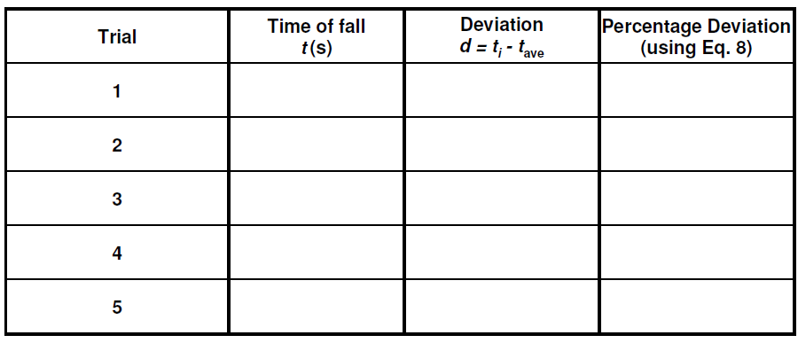

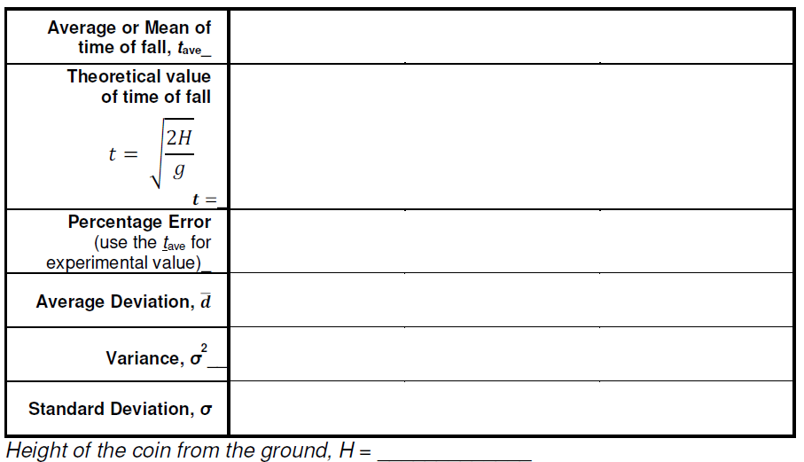

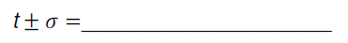

Insert photo(s) of your setup.

Exercises:
- Classify the following as to whether they are
personal, instrumental, or external errors.
_________________ a. incorrect calibration of scale
_________________ b. bias of observer
_________________ c. expansion of scale due to temperature changes
_________________ d. parallax
_________________ e. pointer friction
_________________ f. estimation of fractional parts of scale division
_________________ g. displaced zero of scale

